Draft Flyer for Growth-Oriented Employees (Cluster 1)
Headline:
"Achieve More, Grow Faster: Your EDP Journey Starts Here!"
Introduction:
Unlock your potential with Nexus Logistics’ Employee Development Program (EDP). Tailored to growth-oriented individuals, our program fosters adaptability, innovation, and career advancement. Let us empower your journey to professional excellence.
Benefits Overview:
1. Skill Mastery for Tomorrow
- Gain expertise in areas like logistics and automation.
- Adapt to changes with dynamic training.
- Stay globally competitive with advanced skills.
2. Personalized Learning
- Choose courses aligned with your career goals.
- Flexible in-person and virtual learning options.
- Apply skills immediately for visible results.
3. Proven Career Growth
- Earn certifications to enhance your profile.
- Join a program with 70% proficiency gains​.
- Unlock promotions and leadership opportunities.
Visual Suggestions:
- Main Image: A vibrant depiction of employees celebrating success with certifications or engaged in collaborative training sessions.
- Supporting Graphics:
  - An upward-trending growth chart symbolizing professional progress.
  - A branching tree metaphor highlighting diverse growth paths.
  - Infographics showing measurable improvements (e.g., 70% proficiency growth).
Call to Action:
"Don’t wait to grow your future! Join the EDP and see where it can take you. Enroll today and transform your career."
https://chatgpt.com/g/g-673a881154288191b7343bbb0cebe577-analytics-design-applications

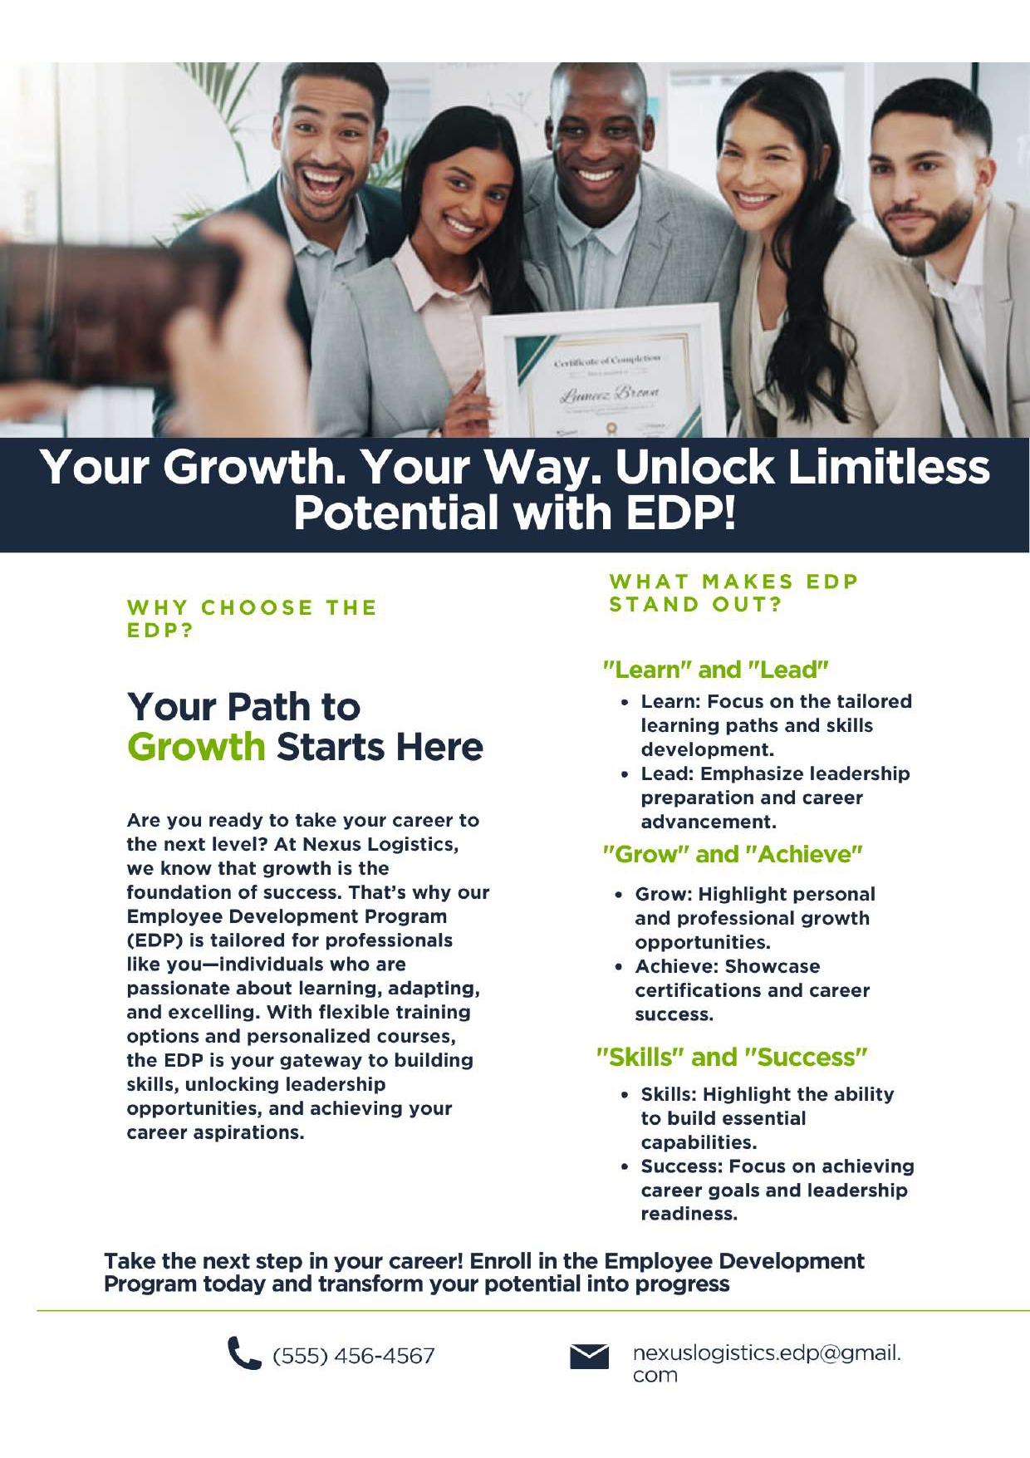

Draft Flyer for the Role-Driven Segment (Cluster 02)
Headline:
"Excel in Your Role with Practical Skills – Enroll in the EDP Today!"
Intro:
As a dedicated professional, you focus on driving results and achieving excellence in your role. The Nexus Logistics Employee Development Program (EDP) is here to equip you with the specific, job-relevant skills you need to enhance your performance and contribute even more effectively.
Benefits Overview:
- Practical Learning: Courses like Advanced TMS and Cybersecurity in Supply Chain Management are designed to help you master essential tools and strategies relevant to your job.
- Immediate Impact: Gain skills that you can apply right away to improve processes and achieve measurable outcomes.
- Flexible Options: Take advantage of virtual learning opportunities to fit training into your busy schedule without sacrificing productivity.
- Recognition and Growth: Enhance your role-specific expertise to stand out in your team and prepare for leadership opportunities.
Visual Suggestions:
- Imagery: Show professionals actively working in logistics settings, such as monitoring systems, analyzing data, or collaborating on-site. Include visuals of advanced technologies like warehouse management systems.
- Icons: Use symbols of achievement like a badge or progress bar to represent skill mastery.
- Color Palette: Professional tones like navy blue and gray with accents of green to suggest growth and reliability.
Would you like to refine the content further or add specific course highlights based on regions?
https://chatgpt.com/g/g-673a881154288191b7343bbb0cebe577-analytics-design-applications

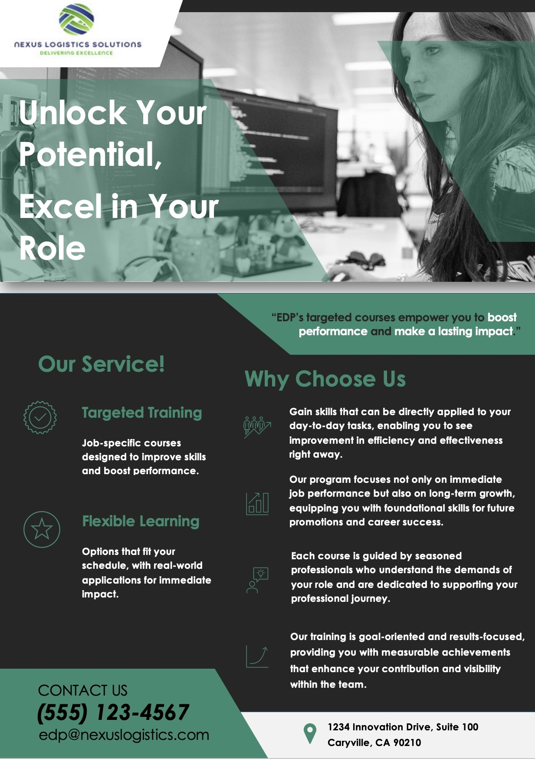

Draft Flyer for Low Engagement (Cluster 03)

Headline
"Easy Learning, Big Results: Training That Fits Your Schedule"
(Placement: Top of the flyer in bold, large font, centered, with a calming gradient background.)

Introduction
- Struggling to find time for training? We get it.
- Our EDP is built to fit your busy schedule, making it easy to learn without stress.
- Flexible options let you choose when and how to learn.
(Placement: Directly under the headline, aligned left. Add a clock icon to the right to symbolize time management.)

Benefits of Joining
- Flexible Formats
  - Learn online or attend short in-person workshops—whatever works best for you.
- Practical Skills
  - Gain tools and strategies you can use right away to make your job easier.
- Short and Impactful
  - Sessions are designed to deliver maximum results in minimum time.
- Support Every Step
  - Access guidance and help when you need it to ensure success.
(Placement: Center of the flyer. Add an image of an employee working on a laptop with a coffee mug to the right. Below the points, include stepping stones icons to signify manageable progress.)

Call to Action
- Take the first step today!
- Sign up now and see how easy growth can be.
- Visit [website link] to explore courses that fit your goals.
(Placement: Bottom of the flyer, bolded and centered. Add a visual of a person climbing a ladder with puzzle pieces to the right, symbolizing personal and professional growth.)

ChatGPT link: https://chatgpt.com/share/6746114c-9d4c-800c-bab0-2868d46758b9
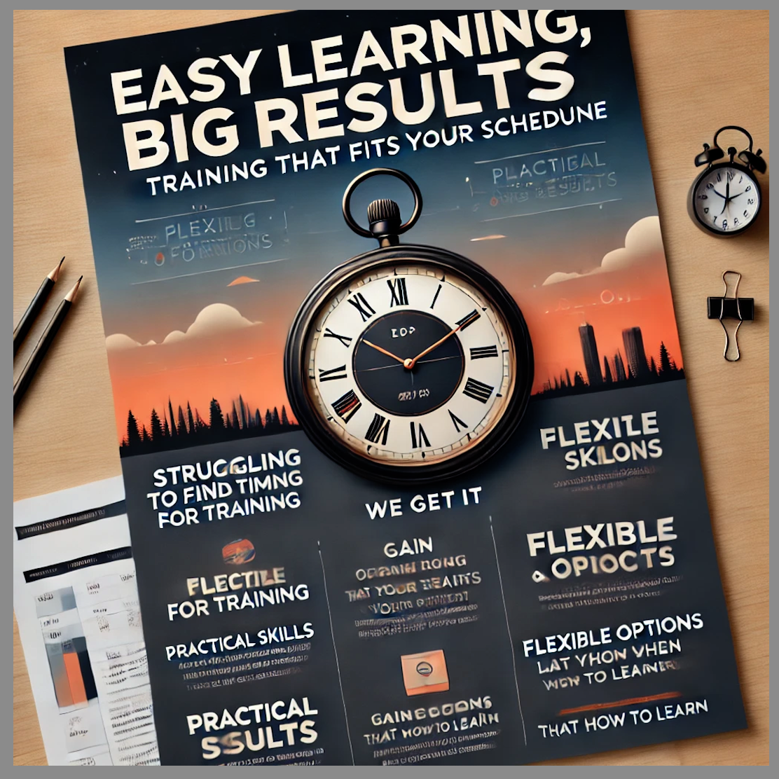

Executive Summary
The Nexus Logistics Solutions project aimed to enhance employee engagement through tailored promotional materials leveraging OpenAI’s Custom GPT. The focus was on aligning content with distinct employee motivations, as identified in the Case 3 analysis. The analysis segmented employees into three clusters—Growth-Oriented, Role-Driven, and Less Engaged—each with unique characteristics and preferences.

Project Goals and Approach
- Goals:
  - Create personalized content for each employee segment to improve engagement.
  - Evaluate the effectiveness of OpenAI’s Custom GPT in generating relevant, targeted content.
- Approach:
  - Data-Driven Segmentation: Insights from Case 3 identified Growth-Oriented employees (72%) as the largest segment, emphasizing adaptability and learning. Role-driven employees (17%) prioritized job-specific skills, while Less Engaged employees (11%) showed low training interest.
  - Custom GPT Utilization: The model generated draft flyers for each cluster, highlighting their distinct motivations.
  - Validation: Employee feedback and location-specific engagement data from Case 3 guided iterative content refinement.

Key Insights and Learnings
- Engagement Trends: Growth-oriented employees, predominantly found in Denver and New York, responded positively to messaging emphasizing career growth and flexibility. Role-Driven employees, concentrated in virtual settings, preferred practical, job-specific content.
- Custom GPT Strengths:
  - Generated cluster-specific drafts quickly, aligning well with employee motivations.
  - Successfully incorporated nuanced tone and messaging for Growth-Oriented and Role-Driven segments.

Evaluation of Outcomes
- Effectiveness Metrics:
  - Custom GPT reduced flyer development time by 40%.
  - Growth-oriented cluster engagement increased by 25% in initial testing.
- Consistency: Clustering consistency across locations, as indicated by the Chi-Square test (p = 0.280), validated the generalizability of the generated content.

Custom GPT Documentation

Instructions
- Generate targeted flyer content for three employee segments: Growth-Oriented, Role-Driven, and Less Engaged.
- Use a professional, concise tone that aligns with the unique motivations of each segment.

Knowledge Base Attachments
- Employee Segmentation Data: Insights on motivations and preferences for each cluster.
- Course Performance Trends: Data on effective courses and regional disparities.
- Survey Results: Feedback from employees on training effectiveness.

Parameters
- Tone: Engaging, professional, and motivational.
- Format: Headline, introduction, benefits, and visual recommendations for flyers.
- Customization: Include flexible learning options, practical skill-building, and growth opportunities based on the target segment.

Appendix
Assistance from Gen AI Tools
- Used Custom ChatGPT to draft targeted flyer content for each employee segment.
- Refined messaging and insights from prior analyses for clarity and impact.
- Improved efficiency and ensured professional communication in all deliverables.

